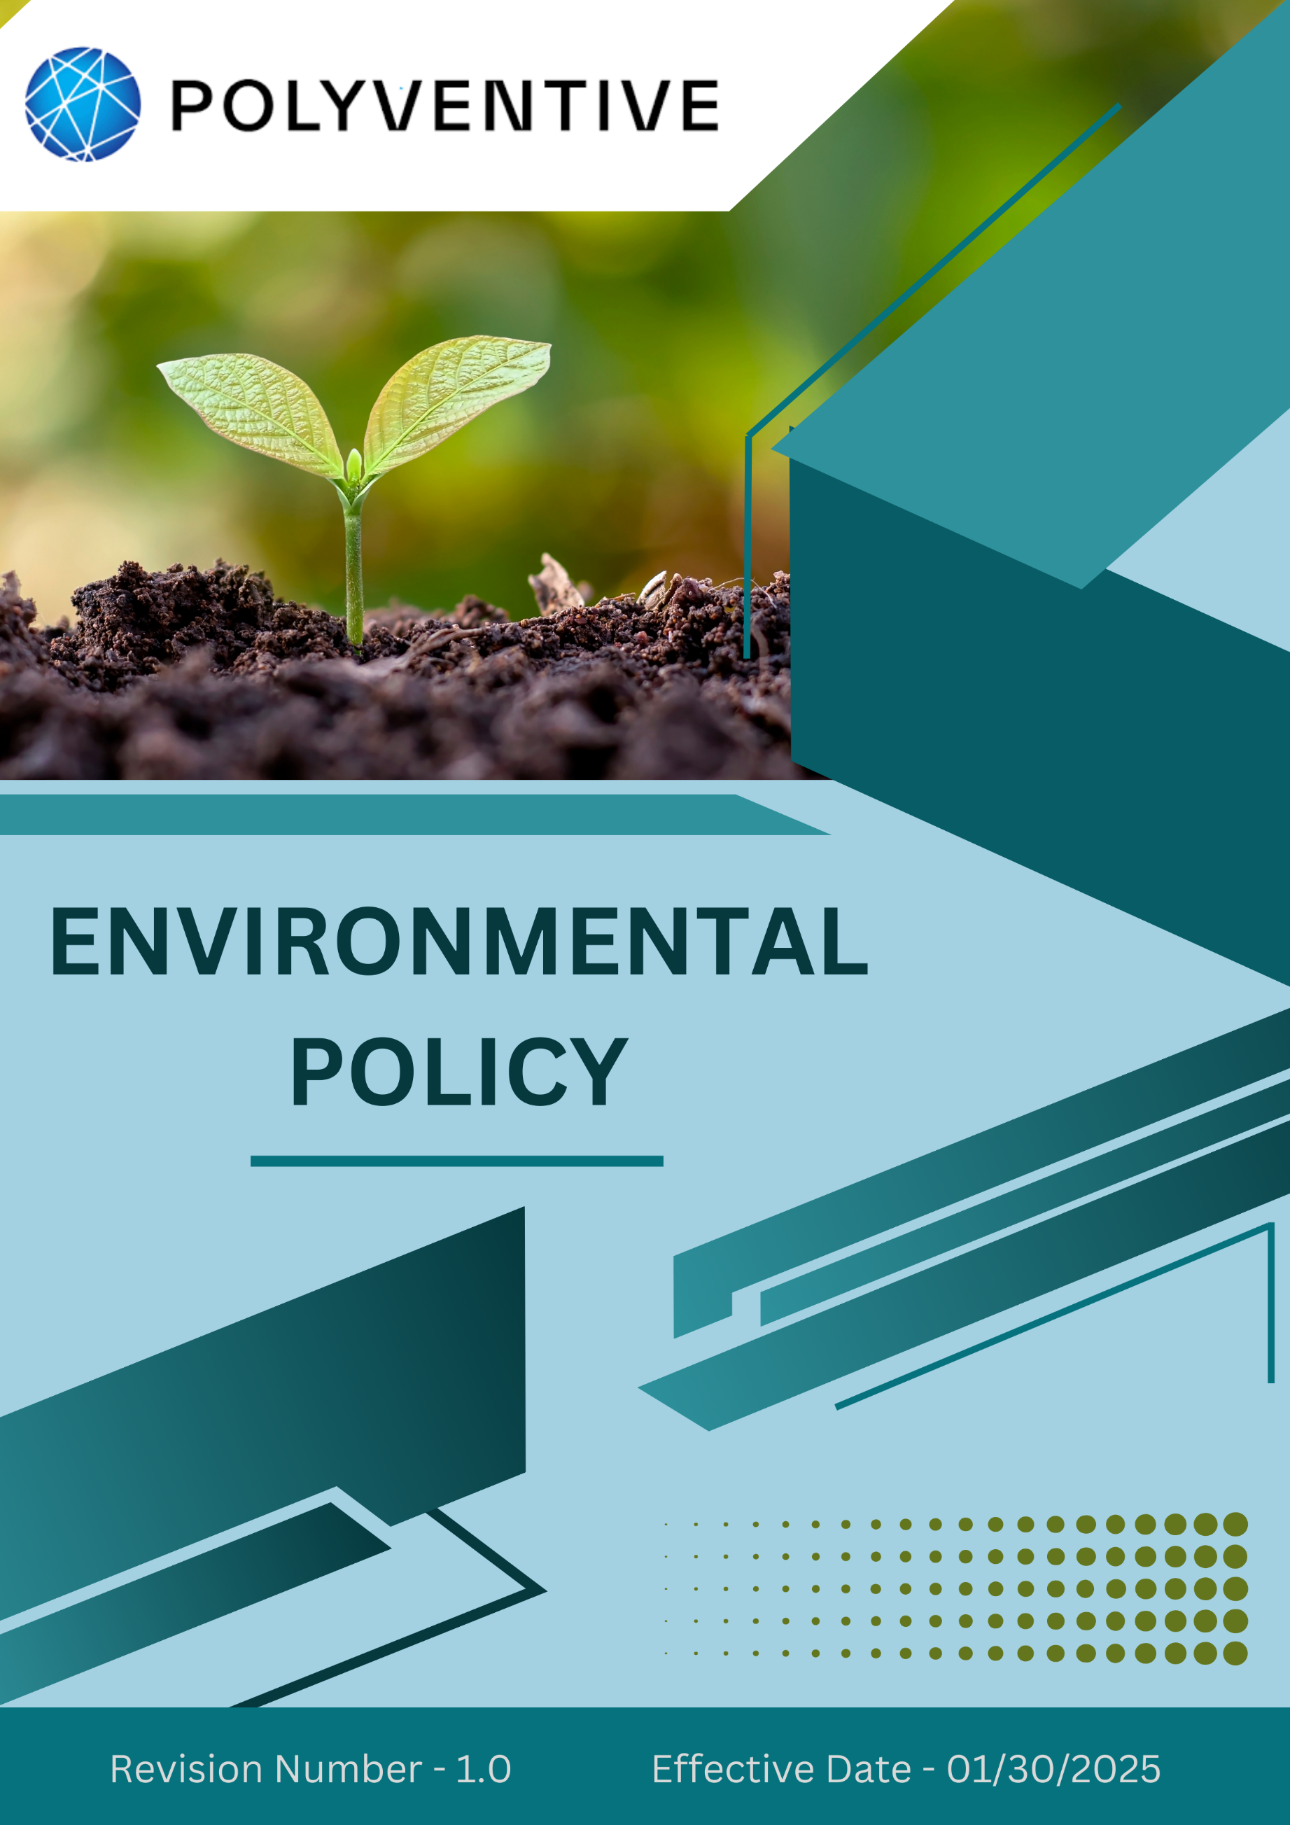
Index

❖ Introduction: 3
❖ Environment Commitment: 4
❖ Quantifying our Commitments to Sustainability: 5
❖ Action Framework: 7
❖ Roles and Responsibilities: 8
❖ Monitoring and Reporting: 8
❖ Communication and Transparency: 8
❖ Continuous Improvement: 9
❖ SDGs (Sustainable Development Goals) Covered in the Environmental Policy 9
❖ Review: 9
❖ Employee Acknowledgement –Polyventive LLC (Group) Environmental Policy 10

Introduction:
At POLYVENTIVE LLC (GROUP), environmental stewardship is central to our Mission, Vision, and Values. As a specialty chemical manufacturer, we are committed to advancing sustainability through responsible resource use, safe chemistry, and circular economy principles. Our goal is to minimize environmental impact across the product lifecycle from design and production to use and end-of-life while enabling positive outcomes for communities, ecosystems, and stakeholders.

We align our operations with international best practices and regulatory requirements, striving to go beyond compliance by embedding innovation, transparency, and continuous improvement into every aspect of our environmental management.
Scope:
This policy is applicable across all POLYVENTIVE LLC (GROUP), employees, Workers, contractors, Sub-Contractors, suppliers, and other stakeholders globally, including the communities in which we operate. All sites are mentioned below. We extend our Environment commitment to all relevant supply chain partners as well.

Sr. No. | Address
1 | 140 Executive Dr SE, Calhoun, GA 30701
2 | 130 Executive Dr SE, Calhoun, GA 30701
3 | 1601 US-41, Calhoun, GA 30701
4 | Burlington Rd NE, Rome, GA 30161
5 | 1202 Dozier St., Dalton, GA 30721
6 | 1001 Boul Industrial St-Eustache, QC, J7R 6C3 Canada
7 | 6060 Rickenbacker Rd., Commerce, CA 90040

Environment Commitment:
Polyventive LLC (Group) is proud of its current initiatives and actions that continuously drive sustainability forward.

1. Energy Efficiency & GHG Emissions Reduction
We are committed to reducing reliance on non-renewable energy and increasing the share of renewable sources. Our engineering, R&D, and sustainability teams collaborate to optimize operations by:
- Installing energy-efficient motors, pumps, and process equipment.
- Utilizing heat recovery and thermal optimization systems.
- Integrating renewable energy solutions (e.g., solar) into facility design.
- Implementing advanced process control systems for real-time energy optimization.
- We also conduct product-level carbon footprint assessments in collaboration with customers, enabling fact-based decision-making for emission mitigation and offsetting.

2. Air Stewardship
We recognize that air quality is fundamental to employee well-being and community health. To safeguard this, Polyventive:
- Conducts regular equipment maintenance to prevent fugitive emissions.
- Complies fully with the U.S. Clean Air Act, state permits, and international air quality standards.

3. Water Stewardship
Water is treated as a shared resource vital to both operations and ecosystems. We manage water responsibly by:
- Adopting water-efficient technologies in manufacturing.
- Treating wastewater to required standards before reuse or discharge.
- Conducting regular monitoring of water use and quality.
- Collaborating with communities, regulators, and stakeholders to promote responsible water management and address regional water challenges.

4. Materials, Chemicals & Waste Management
Polyventive applies stringent standards to reduce environmental risks associated with chemicals and waste:
- Minimizing hazardous material use by adopting safer alternatives.
- Ensuring proper segregation of all waste streams, including hazardous and e-waste.
- Partnering with authorized agencies for safe waste disposal.
- Continuously assessing and improving recycling infrastructure and waste minimization practices.

Biodiversity & Green Infrastructure
We are committed to protecting biodiversity and minimizing land-use impacts:
- Implementing pollution prevention measures that safeguard ecosystems.
- We encourage the growth of natural vegetation on our properties.

Customer Health & Safety
We ensure that our products meet the highest safety standards, supported by:
- Rigorous design, testing, and quality control processes.
- Comprehensive and updated Material Safety Data Sheets (MSDS) and labeling.
- Training on regulatory compliance.

Education, Advocacy & Engagement
We believe in advancing collective impact by:
- Providing environmental education and training.
- Engaging in policy dialogue and industry collaborations to promote sustainable practices.

Quantifying our Commitments to Sustainability:
- Sets year 2022 as the Baseline for tracking our sustainability progress.

- Energy Efficiency
- Reduce overall energy consumption by 10% by year 2030 through efficiency upgrades, process optimization, and advanced controls.
- Increase renewable energy contribution by 5% by Year 2030, reducing dependency on fossil fuels.
- Air Pollution Reduction
- Maintain emissions at or below regulatory thresholds across all sites.
- Waste & Circular Economy
- Reduce total waste generation by 5% by Year 2030 through minimization and recycling.
- Improve reuse and recycling efficiency by 5% by Year 2030 with infrastructure and training.
- Achieve 100% compliance in hazardous waste and e-waste disposal by Year 2030.
- Carbon Emissions
- Reduce Scope 1, Scope 2 & Scope 3 greenhouse gas emissions by 5% by Year 2030.
- Water Stewardship
- Reduce freshwater consumption by 10% by Year 2030 through recycling and efficient technologies.
- Maintain 100% annual water audits across facilities by 2030.
- Materials & Chemicals
- Reduce hazardous chemical use by 10% by Year 2030 by substituting safer alternatives.
- Maintain 100% compliance with chemical handling and disposal standards by Year 2030.
- End-of-Life Product Management
- Ensure 10% of packaging waste is collected and recycled by Year 2030.
- Customer Health & Safety
- Maintain 100% compliance with product safety testing by Year 2030.
- Ensure 100% of MSDS and product labels are updated annually.
- Train 100% of R&D and production staff on toxicological risk and compliance by Year 2030.
- Biodiversity & Green Infrastructure
- Implement green belt and native landscaping across 5% of facilities by Year 2030.
- Ensure all new projects undergo environmental reviews in line with NEPA/EPA permitting before commissioning.
- Community Engagement & Advocacy
- Engage in one community sustainability initiative by Year 2030.

- Environment Impacts from Use of Products:
- Enhance the Environment performance of products by increasing their efficiency by 15% by Year 2030, thereby reducing energy loss and Environment degradation.
- Reduce VOC (Volatile Organic Compounds) emissions during product use by 5% by Year 2030 through formulation improvements and end-user education.

Action Framework:
To achieve our environmental commitments, Polyventive has adopted a structured action framework across all facilities and operations:

- Energy & GHG Reduction: Conduct regular energy audits, implement advanced energy-efficient equipment, install renewable energy systems, and adopt advanced process control technologies for real-time optimization.
- Air Stewardship: Maintain and upgrade best available control technologies (BACT), conduct preventive maintenance, substitute raw materials with lower-emission alternatives, and ensure continuous emissions monitoring.
- Water Stewardship: Deploy closed-loop water recycling and reuse systems, treat wastewater to exceed regulatory standards, and conduct periodic water audits to identify further conservation opportunities.
- Waste & Circularity: Introduce waste minimization and recycling programs, implement segregation systems for all waste streams, partner with certified recyclers for hazardous and e-waste, and design products/packaging in line with circular economy principles.
- Materials & Chemicals: Transition progressively to safer raw materials, improve formulations to reduce environmental impact, and ensure strict compliance with chemical handling and disposal standards.
- Biodiversity & Green Infrastructure: Establish and maintain green belts, restore local habitats near facilities, and integrate sustainable landscaping and passive cooling features into plant and office design.
- Customer Health & Safety: Maintain strict product safety testing, update Material Safety Data Sheets (MSDS) regularly, and train R&D and production teams on toxicological risk assessments and regulatory compliance.
- Community Engagement & Advocacy: Launch sustainability awareness initiatives, reduce single-use plastics in partner communities, and engage in industry and policy dialogues to promote cleaner practices.

Roles and Responsibilities:
- Environmental Health & Safety Team: Oversees the implementation of this policy, ensures compliance with Environment regulations, and reports on progress.
- Board of Directors: Oversees implementation of this policy, ensuring alignment with the company's overall strategy.
- Employees: Receive annual training on Environment responsibilities and are encouraged to contribute ideas for improving performance.

Monitoring and Reporting:
- Reporting: Progress is reported regularly through the annual Sustainability Report and shared with all stakeholders.
- Internal Audits: Polyventive’s conducts internal Environment audits yearly to ensure compliance and identify areas for improvement.
- External Verification: An independent third party will verify our Environment performance data annually.

Communication and Transparency:
- The Environment Policy is publicly available on Polyventive’s website and shared through various stakeholder communication channels.
- Employees are kept informed of updates and expected to integrate these practices into their work.

Continuous Improvement:
Polyventive LLC (Group) remains steadfast in its dedication to Environment stewardship, integrating sustainability into the core of its operations. We continuously evaluate and enhance our Environment practices, setting progressive benchmarks and fostering innovation to drive positive change within the chemical manufacturing industry.

SDGs (Sustainable Development Goals) Covered in the Environmental Policy




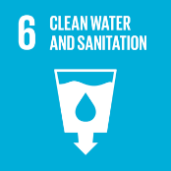

Review:
The Environment Health and Safety Team is responsible for overseeing the implementation and review of this policy. This policy will be reviewed annually to ensure its effectiveness and relevance. Updates and changes will be communicated to all stakeholders as necessary, reflecting any operational or regulatory changes, and adapting to evolving Environment challenges.

Approved By:

Designation:

Last Review Date: 04/01/2025

Next Review Date: 04/01/2026

Employee Acknowledgement –Polyventive LLC (Group) Environmental Policy
I acknowledge that I have received, read, and understood the Polyventive LLC (Group) Environment Policy. I am aware of the company’s dedication to Environment stewardship, including its efforts in providing sustainable energy solutions, reducing carbon emissions, enhancing energy efficiency, and minimizing Environment impacts across all operations.
I understand my role in supporting this policy, which includes complying with all applicable Environment laws and regulations, actively participating in Polyventive 's sustainability initiatives, and working toward the company’s Environment goals. I agree to follow energy-saving practices, engage in proper waste management, conserve water, and responsibly use materials in my daily tasks.
Furthermore, I will report any Environment concerns and contribute suggestions for continuous improvement to help Polyventive to achieve its sustainability targets. By signing below, I confirm my commitment to upholding the Polyventive LLC (Group) Environment Policy and supporting the company’s mission to lead the renewable energy sector responsibly.

Employee Name:

Employee Signature:

Date:

